Brno Museum Night 2011
Saturday 14. 5. 2011
18.00–24.00
www.brnenskamuzejninoc.cz
press release of 9. 5. 2011

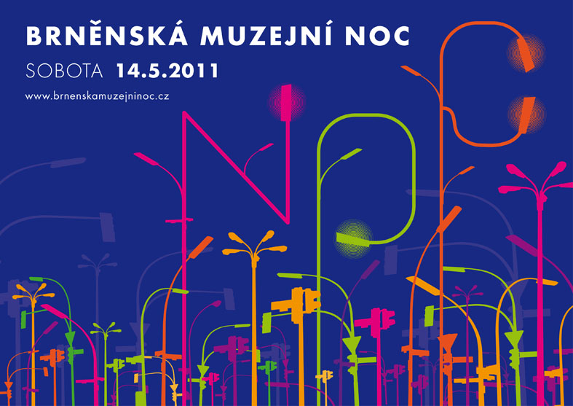

This year’s Brno Museum Night is going to be held for the seventh time and takes place on Saturday, 14th May. In view of the previous successful events we are convinced that it has become a brand that needs no introduction. Almost everybody in and around Brno knows that the phenomenon of the Brno Museum Night encompasses free guided tours of permanent exhibitions after dark, dozens of attractive temporary exhibitions, art workshops, lectures, concerts, theatre performances, food and beverage tasting, examples of handicrafts, fashion shows and much more. However, each year manages to offer something new with the potential to pleasantly surprise. Apart from the rich cultural programme the organizers are again searching for a way of how to exploit the potential of the Brno Museum Night for the rest of the year. We will do our best to receive feedback from our work and what we provide in terms of free-time activities.
Marek Pokorný, director of the Moravian Gallery in Brno, which for the third time has taken on responsibility for managing the whole event, adds: “Every year during the Museum Night we do our best to show people that we have something to offer not just once in a year but almost every day. However, there are no significant increases in the number of regular visitors to the galleries. We would like to find out why. What can we do so that people would visit exhibitions more often? In what way might the galleries and museums deter and, on the contrary, attract visitors? We do care about the opinion of the public. We feel sure that it can help us to improve.”
Visitors to the Brno Museum Night can voice their opinion by means of a questionnaire (printed or electronic) and a special area will be reserved for this purpose in each of the participating buildings. Another option of giving comments is available to facebook users on the official page of the Brno Museum Night at http://www.facebook.com/brnenskamuzejninoc and the public can also share their views thanks to the Brno Museum Night Check-in. It is being developed by Martin Hassman and Marek Lutonský on the request of the the Moravian Gallery in Brno. Visitors will be able to check-in at more than thirty locations with exhibitions and cultural programmes. For those who have never checked in before and would like to give it a try for the first time on Saturday 14th May, the Brno Museum Night Check-in web page at http://www.facebook.com/brnenskamuzejninoc#!/brnoc will provide detailed instructions for working with both the Foursquare and Gowall applications. People will have a chance to be informed in real time at which museum their friends are at that very moment and what they like there.

HIGHLIGHTS FROM THE PROGRAMME OF THE PARTICIPATING INSTITUTIONS

This year three galleries/museums from Brno celebrate important anniversaries: the Moravian Gallery in Brno and the Technical Museum in Brno celebrate fifty years and the Museum of Romany Culture twenty years from their foundation.
The Moravian Gallery in Brno based its accompanying programme on the nine current exhibitions. The Museum of Applied Arts, the ground floor of which has been filled with Oriental art, will this year stage an art workshop entitled A Thousand Ornaments and One Night and a performance by the Jumping Drums group of drummers. In the Pražák Palace, which is showing the Plane, Depth, Space exhibition, there will be held a Workshop on a Perspective Theme prepared by Tomáš Vaněk. The exhibition of photographs by Viktor Kolář in the Governor’s Palace will be accompanied by a concert of the Betonovej bez band. Visitors to the night events will undoubtedly also be pleased by the opportunity to buy catalogues and publications at specially reduced prices.
The programme of the Brno City Museum in Špilberk Castle will have the flavour of a Gothic festival and will offer fencing, theatre and dance performances, and in the Gothic Hall in the Small Courtyard there will be poetry by contemporary Brno poets set to music. Visitors can also see the oldest comic — a replica of the famous Bayeux Tapestry that captures the conquering of England by the Normans. The south-west bastion will again be transformed into an astronomical observatory for watching the museum night sky over Brno. A night premiere of the Toy Museum will take place in the Měnínská Gate. The Technical Museum in Brno wants to lure the public to an exhibition of interactive objects with the title Orbis pictus PLAY and promises to bring its permanent exhibitions to life by animators in period costumes and uniforms.
The events in the Moravian Museum will include an exhibition of puppets (Dietrichstein Palace), examples of decorating Easter eggs (Bishop’s Court), a multicultural evening with a fashion show (Noble Women’s Palace), an Arabian café, a circus and reggae music (Anthropos Pavilion). During the Museum Night the Moravian Museum will again open the doors of some of its other buildings ― the Leoš Janáček Museum on Smetanova St. and the Kralice Bible Memorial in Kralice nad Oslavou (special public transport night line not provided).
The Brno House of Arts will make both of its buildings accessible to the public and parts of the programme will also take place in the newly opened Leporelo+ café. The building on Malinovského Square will feature, apart from interesting exhibitions, a Fashion Show and a concert by the Burningboy band. In the House of the Lords of Kunštát in Dominikánská St. the exhibitions will be accompanied by special animation programmes and the popular Artjarmark. The Museum of Romany Culture comes with a host of music performances, an art workshop dedicated to working with beeswax and tasting traditional Romany food. Visitors to the Mendel Museum can enjoy the permanent exhibition, a traditional quiz and a peek into the beehive. The Diocesan Museum is staging a drama performance called the Jacobian Stories by the students of the JAMU in the area around the cathedral on Petrov Hill.
The programme of the Museum of the Brno Region in Rajhrad will be dedicated to the one hundredth anniversary of the birth of Zdeněk Jirotka, the Peace Monument in Prace will be host to a concert of the Mladost women’s choir and in Předklášteří curious visitors can delve into the Men’s World. The Brno Cultural Centre is preparing a mini festival of dances from around the world, a taste of the approaching Brno Theatre World festival and an opportunity to climb the stairs of the Old Town Hall tower and be enchanted by the view of Brno at night. As part of the programme entitled May I Have This Dance? held in the Jiří Mahen Library visitors will see a theatre play, dance and singing performances and an Oriental dance school.
The Galerie Sklepení prepared for this year a programme focusing on flowers and their arrangement. The Villa Stiassni, another building of the local branch of the National Heritage Monument Institute opened to the public, will put on show works by the students of and fresh graduates from the FA VUT. Visitors to the HaDivadlo Theatre will see an excerpt from the improvised debate Café MAKAK. The “Red” Church will offer traditional organ music concerts and an exhibition dedicated to the history and the present of the Unitas Fratrum. The Brno Observatory and Planetarium is closed due to reconstruction and the prepared programme will take place in Špilberk Castle and the Jiří Mahen Library.
The official guest in 2011 — the National Theatre Brno – will open the doors of all of its buildings to the public after the end of their evening shows. During the Museum Night there will be three performances in the Janáček Theatre of an art show entitled Four Heartbeats / Horizontal Theatre conceived by Daniel Dvořák. Another show, King Richard III, will take place in the Mahen Theatre in the form of a screened event. The Reduta Theatre is offering an excerpt from the Sinfonietta VideoART project.
The programme of the Brno Museum Night is so rich and varied that it will undoubtedly be a good idea to plan ahead your itinerary of exhibitions and cultural events. You will be helped in this by a printed programme brochure available in all of the participating institutions and from Saturday 11. 5. also from the info bus in Náměstí Svobody. Alternatively, the web pages www.brnenskamuzejninoc.cz, contain a detailed programme and all the other organizational details in Czech, English, and for the first time in German as well.

BRNO MUSEUM NIGHT CHECK-IN

The first Museum Night Check-in in the country happened on 12th June, 2010 in Prague and was organized by the famous Prague technology enthusiast and software developer Martin Hassman. As the chief organizer of the Brno Museum Night, the Moravian Gallery in Brno invited him to make arrangements for a similar event in the Moravian metropolis. Martin Hassman joined forces with Marek Lutonský, another specialist who is in charge of the web portal of the Mladá fronta daily, and other volunteers to help adapt the event to the Brno environment they are familiar with. The result is the Brno Museum Night Check-in, welcoming all who are in possession of a smart mobile phone and some form of a mobile data connection to the internet. Complete beginners will be furnished with detailed instructions on where to download the necessary Foursquare or Gowalla software, how to use it, what to avoid and what to indulge in.
So that those participating in the check-in fun on Saturday 14th May can distinguish themselves in the crowds the organizers have adopted a dress code – a white T-shirt. Participants will be able to check in at more than thirty locations with exhibitions and cultural programmes. The organizers recommend that, apart from the actual check-in, they share their impressions and photographs as during the night these will be accessible on the web pages of the Brno Museum Night. Alongside virtual objects and points the participants in the Brno Museum Night Check-in will be rewarded by a special after-party in one of Brno’s cafés where the first thirty people to arrive will receive an original badge with the event logo.
And what is Foursquare and Gowalla? They are currently the two most popular entertainment services based on locating using mobile phones. Within a group of friends you can let the others know where you are at the moment, in which restaurant, railway station or museum. After touching a button in the mobile application — or checking-in — your friends immediately learn what place you have just visited. More at www.facebook.com/brnoc.

The Brno Museum Night is held under the auspices of Roman Onderka, the mayor of the City of Brno, Michal Hašek, the head of the South Moravian Region, and Vojtěch Cikrle, the Bishop of Brno. It is part of the Museum Night Festival organized by the Czech Association of Museums and Galleries with support by the Czech Ministry of Culture. It takes place with the financial support of the City of Brno and with a significant contribution by the Brno Transport Authority which provides free transport for visitors to the exhibition buildings outside the city centre.

PARTNERS:

The event takes place with financial support from the Czech Ministry of Culture and the City of Brno
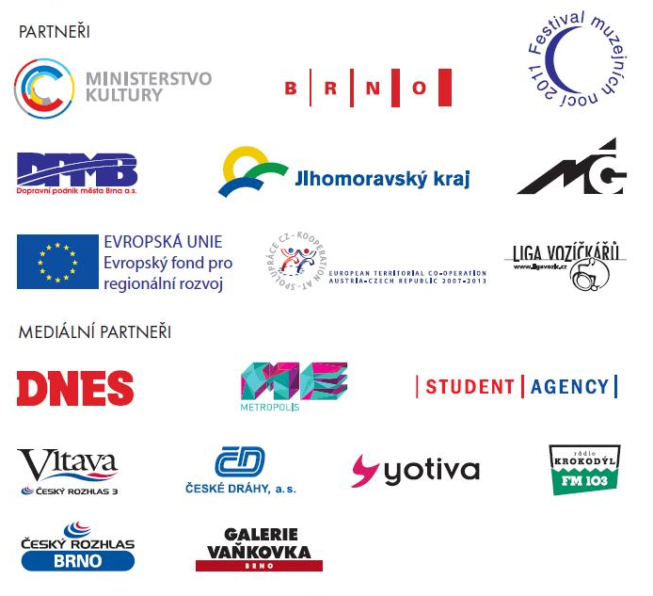

BRNO MUSEUM NIGHT ORGANIZERS:

Moravian Gallery in Brno, Brno City Museum, Technical Museum in Brno, Moravian Museum in Brno, Brno House of Arts, Museum of Romany Culture, Museum of the Brno Region, Mendel Museum of Masaryk University, Diocese Museum

Jiří Mahen Library in Brno, National Heritage Monument Institute, Brno branch, HaDivadlo Theatre Gallery, Brno Cultural Centre, Brno Observatory and Planetarium, “Red Church”

National Theatre Brno — Guest Participation in 2011

