Czechs and panels. Paneland will share the story of the unique phenomenon.
Press release of 23 November 2017
For over two and a half million people they are home. They have families with children and individuals, people of all ages, both the rich and the poor. These are the panels, an unusual phenomenon of the former Czechoslovakia, which is still alive and still evolving. The Moravian Gallery in Brno offers an unusual view of the relics of the communist regime, fifty years from the mass construction of panel housing estates. In addition to a typical panel apartment, "Husákova 3 + 1," the exhibition will also present photographs, design and fashion from the time of the standardization of these buildings, as well as projects by contemporary artists. The exhibit will both show, and change, the perception of these settlements during the last half-century.
PANELAND. THE BIGGEST CZECHOSLOVAK EXPERIMENT
Curator: Rostislav Koryčánek
Architect of the exhibition: Tomáš Džadoň
Illustration: Jan Šrámek

Museum of Applied Arts, Husova 14
November 24, 2017 – March 18, 2018

With a bit of exaggeration, it could be said that Czechoslovakia changed to "Paneland" during the 1970s and 1980s. That is why the authors of the exhibition, which deals with the phenomenon of this way of living, chose this pun for the name of the exhibition. It refers to the massive construction of panel housing estates, which was linked to the need to move people to industrial centers. This resettlement can be considered the "Greatest Czechoslovak experiment." The curator of the exhibition Rostislav Koryčánek explains, "Finding the key to how to handle the housing estates' environment was a challenge not only for the inhabitants themselves, but also for the scientific teams that dealt with this problem from the point of view of architecture, urbanism, sociology or psychology."

Along with the panel housing estate, an entirely new lifestyle was born – "panel culture." The exhibition will approach this lifestyle thanks to archival video, missing photographs, period furniture, design and fashion. Viewers will be reminded of a typical flat apartment by Husák´s 3 +1, a reconstruction of the apartment, which was created during the seminar of Lady Hubatova-Vacková at the Academy of Arts, Architecture and Design in Prague in 2007. The standardization of housing is closely connected with the furniture designed by Jindřich Halabala – U101, which was used most frequently in these flats, which perform the role of walls and showcases at the exhibition.

The Moravian Gallery took interest in the panel houses at the instigation of the Chief Currator Ondřej Chrobák, who was interested in the communist period and the associated housing culture, the exhibition was preceded by the Bulletin Normalization. The work of the Museum of Applied Arts in Prague has confirmed the accuracy of this exhibition. "Extensive research into the architecture and urbanism of the panel housing estates in the Czech Republic has been completed by the Museum of Decorative Arts in Prague this year, which, with the support of the grant project NAKI of the Ministry of Culture, has been carried out in all regions of the Czech Republic exterior exhibitions on the subject. The collective exhibition, which will detail the development stages and personalities of the Czech housing estates, as well as the disposition of the dwellings and the transformation of this housing culture period, will open at the Prague UPM to the public on 18 January 2018. The two major publications are the Panelists I. and II.” adds Helena Koenigsmark, director of the Museum of Applied Arts in Prague.

Paneland also includes leading Czech designer Maxim Velčovský, who is presenting a space installation of pressed glass to evoke the Brno panel housing estate. There are also interactive features that will especially appeal to young visitors - functional telephone lines, climbing cubicles, and miniature furniture, from which you can create your own apartment. In their studio, children can play retro games or participate in the project of Jiří Černický, who will create panel rooms from the materials used here (see annex 1).

The exhibition Paneland by the Moravian Gallery also launches the international project MADE IN CZECHOSLOVAKIA organized in cooperation with the Slovak National Gallery (for more see the annex
2). Both institutions took advantage of the opportunities of the coming year 2018 and would like to remember that, between 1918 and 1993, our homelands formed a common state, Czechoslovakia. "MADE IN CZECHOSLOVAKIA is not so much a project, but rather a manifestation, a spontaneous approach to the theme, partnership and cooperation. The Slovak National Gallery with the Moravian Gallery in Brno intensively cooperated during the last year, this partnership helped to bring both galleries collections online. An important motivation for organizing a joint project was the consideration of the First Republic. The young state was built on modern foundations and included a strong marketing campaign. Although Czechoslovakia does not exist today, in many contexts, this 'brand' still exists. The project is a recognition of the commonality and confirms the natural need to try something together, to start or just to remind yourself of everything that has disappeared over time,” adds Alexandra Kusá, director of the Slovak National Gallery.

Media Contact

Michaela Paučo
Spokeswoman
E-mail tisk@moravska-galerie.cz, T: +420 532 169 174, M: +420 724 516 672
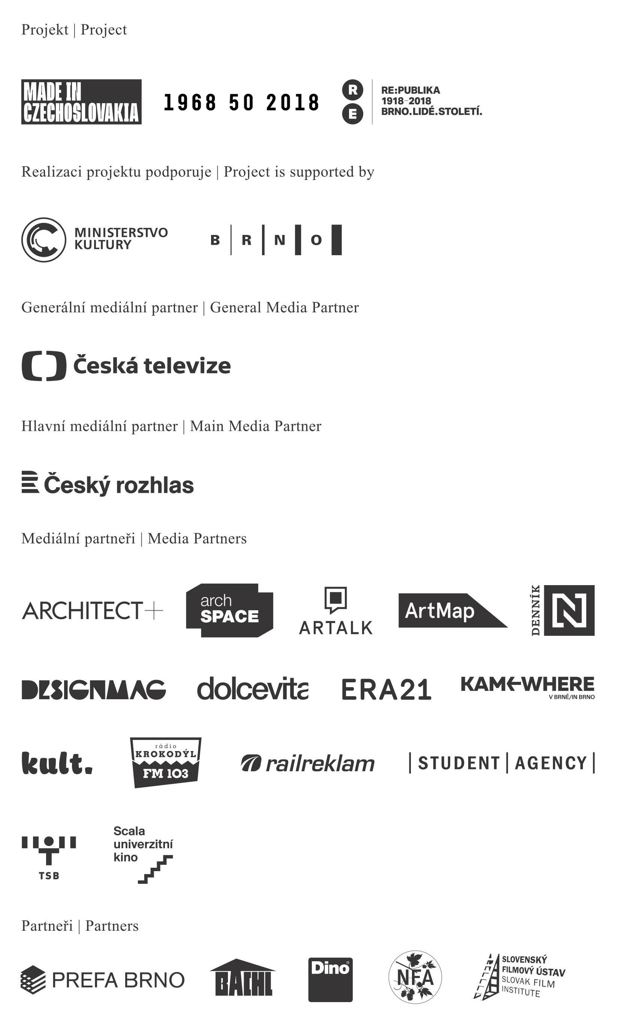
Annex to Press Release No. 1

Accompanying program of the Paneland exhibition

CHILDREN’S OPENING 23. 11. 2017 from 16.00
During the children's opening, the children themselves will try to build a settlement, they will be able to ride on the model of the legendary Tatra T148 and compete for it. They will be the first to go through the exhibition and the opening will end with a dance at a retro disco with refreshments.

WORKSHOPS WITH ART
There will be presentations of works by contemporary artists reflecting on the topic of panel housing coinciding with workshops for children and adults with selected artists. The first workshop will be held with Jiří Černický, holder of the Jindřich Chalupecký Prize.

Workshop with Jiří Černický 25. 11. 2017 from 14.00 to 18.00
At this workshop we will make a creative placement of rooms that symbolize apartment blocks. We will try to find suitable material in the nature and in the collection yard, and we will meet not only the artist, but also see his work and the Paneland exhibition. Suitable for families with children, reservations are necessary.

CHRISTMAS IN PANELAND

Mikulášská besídka 5. 12. 2017 from 17.00
Devils, angels and st. Nicholas will also visit Husák´s 3 + 1 this year. Come and experience with the children an unrepeatable Nicholas directly in the Paneland exhibition. For each child, Nicholas has
a small gift.

Advent Saturdays 2. 12., 9. 12. and 16. 12. 2017 from 14:00 to 18:00

On three special Advent Saturdays there will be a Christmas program in Paneland. There will be a christmas tree, decoration of blockboy gingerbread men, Christmas shows of 70s and 80s, small refreshments and pre-Christmas discounts at the Designshop. Every Saturday there is a special workshop inspired by the traditions that survived socialism: for the first weekend we will make, for example,
Christmas Flower Decorations and Advent Wreaths.

COMMENTED REVIEWS

Do you want to learn more about the exhibition? Come and see Paneland in the company of curator Rostislav Koryčánek and the author of accompanying program Kateřina Minaříková. In the beginning of spring we will also hold guided tours of the Brno housing estates.

STAFF STATISTICS AND FAMILY RESIDENTS

During January, February and March, children and their parents are invited to the exhibition. There will be a number of weekend programs associated with Paneland's themes including an exhibition tour and creative activities.

For more information about accompanying programs visit www.moravska-galerie.cz, Facebook Moravian gallery galerie for kids (Moravská galerie dětem), e-mail edukace@moravska-galerie.cz and tel. +420 532 169 177. It is also possible to arrange school groups via email and phone.

Annex to Press Release No. 2

Exhibitions and events within the MADE IN CZECHOSLOVAKIA project

1. Paneland. The largest Czechoslovakian experiment
Museum of Applied Arts, Brno; 24. 11. 2017–18. 3. 2018
The Paneland Exhibition at the Museum of Applied Arts follows the massive migration to panel housing estates in the 1970s. The exhibition will also deal with how post-revolutionary artists responded to the panel housing estates.

2. Eight
Esterházy Palace, Bratislava; 28 February 2018-31. 12. 2018
The basis of the exhibition will be a three-meter-long wall - a board on which a collage will alternate in time order. The result is meant to be a reminder of socialist obstetrics.

3. 1968: //computer.art/sykora_valoch
Pražák Palace, Brno; 20. 4. 2018-5. 8. 2018
The relaxation of political conditions in the 1960s will be commemorated by an exhibition called Computer Art in Prague's Pražák Palace, which will show how Czechoslovak artists were able to respond quickly, and well, to the new direction of foreign artwork even during the socialist environment.

4. Filla - Fulla: The Fate of the Artist
Esterházy Palace, Bratislava; July 2018-October 2018
The Slovak National Gallery will recall the formation of two classics of Czech and Slovak art - Emil Filla and Ľudovít Full. Both are among the most prominent figures of Czech and Slovak art of the 20th century, both of which opened new and radical developments and introduced new avant-garde approaches to domestic art.

5. High Path. Josef Šíma
Governor's Palace, Brno; 26. 10. 2018-24. 2. 2019
The first Republic and its strong ties to Czech-French relations will be presented by Josef Šíma in the Governor's Palace. Through Josef Šíma, who had lived in France since the early 1920s, progressive artists of the young Czechoslovak Republic could come into contact with artists from France who set the tone of contemporary art. In addition, thanks to the disintegration of the Austria-Hungary empire, they were no longer in a position of inferiority and could establish self-confident partnerships with avant-garde groups, such as the Le Grand Jeu or the Surrealist Group.

6. Collections online
Both institutions, the Moravian Gallery in Brno and the Slovak National Gallery, worked together to publish their collections online.

